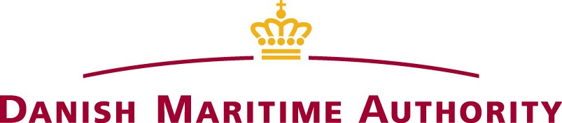
FORM 2
AMENDMENTS TO THE CONTINUOUS SYNOPSIS RECORD (CSR) DOCUMENT NUMBER FOR THE SHIP WITH IMO

If changes occur to previous entered CSR information, the Owner/Master of Vessels under Danish flag to which the CSR regulations applies1, shall forward the additional/revised information by filling in this form and forwarding it to the Danish Maritime Authority as described in the end of this form.

Additional blank forms may be downloaded from the Danish Maritime Authority’s web site at the address: www.dma.dk.

The amendments are shown in the table. Indicate N/C for all items not being changed. Dates shall be in the format yyyy/mm/dd.
Info. No. | Information item according to SOLAS Chapter XI-1, reg. 5.3 | Information
1 | This document applies from (date)
2 | Flag State | Denmark
3 | Date of registration with the State indicated in 2
4 | Name of ship
5 | Port of registration
6 | Name of current registered owner(s) and their  registered address(es)
7 | Registered owner identification number
8 | If applicable, name of current registered bareboat  charterer(s) and their registered address(es)
9A | Name and registered address(es) of Company  (International Safety Management)
9B | Address(es) of its safety management activities
10 | Company identification number
11A | Name of the primary classification society with which  the ship is classed
11B | If applicable, name of the classification society with  which the ship is dual classed
12A | Administration / Government / Recognized Organization which issued Document of Compliance  (DOC)
12B | Body which carried out audit (if different)
13A | Administration / Government / Recognized Organization which issued Safety Management  Certificate (SMC)
13B | Body which carried out audit (if different)
14A | Administration / Government / Recognized  Organization which issued International Ship Security Certificate (ISSC)
14B | Body which carried out verification (if different)
15 | The date on which the ship ceased to be registered in  Denmark
16 | Remarks (Insert relevant information as appropriate)

Information number 17 and 18 below are included to facilitate a complete record at the DMA. The DMA will be very grateful if this information is supplied in addition to the required items.

Info. No. | Additional information item | Information
17A | Administration / Government /  Recognized Organization which issued remaining statutory certificates2
17B | Body which carried out survey (if different)
18 | Maximum deadweight (DWT)

THIS IS TO CERTIFY THAT this record is correct in all respects

Issued by the Company or master of the vessel:
Place and date of issue:
Name of authorized person:
Phone number of authorized person:
E-mail address of authorized person:

Signature of authorized person:

The original form may be attach to the current CSR Document in the ships CSR file.

A copy of the form may be submitted by: e-mail srg@dma.dk or ordinary mail to:

Danish Maritime Authority

Register of ships Caspar Brands Plads 9 DK-4220 Korsør Denmark

